QuPath - Practical 1

Objectives:
- Opening files with Bio-formats
- Cell segmentation
- Cell classification
- Use the workflow and scrip editor tools
- Batch analysis
- Appreciate the benefits of QuPath for standard 2D cell-culture analysis

Add images to QuPath
- In this practical we’ll be looking at images of cultured cells where we’re trying to quantify senescent cells. Channels are Brightfield, F-Actin, Senescence-associated Beta Galactosidase (SAB), and DAPI (nuclei).
- Begin by making a new QuPath project
- Add “Example lif project.lif” (drag and drop in to open QuPath session window)
- You can choose “Bio-Formats” to open this file or “Let QuPath Decide” (it knows this is the correct thing to do!)
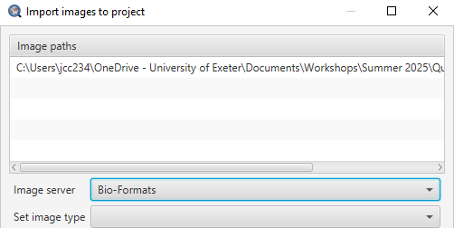
- You’ll now see all the images in the Project tab
- It loads all the images easily
  - Note, unlike ImageJ, these are not actually being opened yet. This is done one at a time.
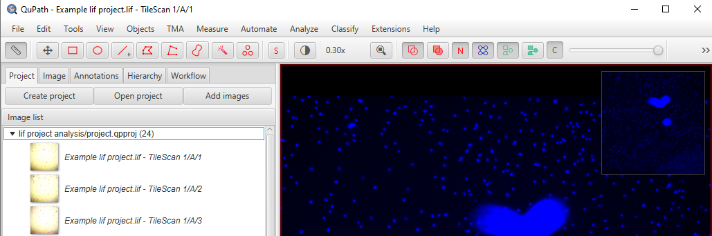

Cell Detection
Note1. Look at the image channels using Shift + C
Note 2. Commands can be searched using Ctrl + L
- Select a region of the image using the rectangle tool
  - This must be done somehow to choose which region to work in (we’ll come back to this!).
- Then run Cell Detection on Channel 4 (DAPI)
  - Search for this command or follow tabs Analyse >> Cell Detection >> Cell Detection
  - Use the settings in the image below
  - Run
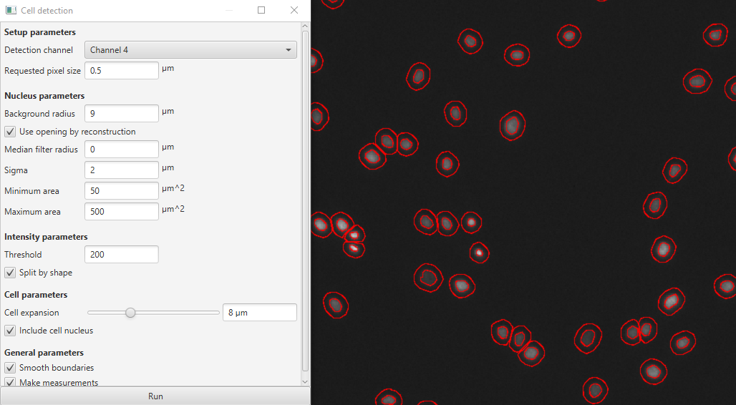

Classify based on Channel 3 brightness
- Go to the Annotations tab
- Add a new class called “Senescent”
- Classify the cells based on their cytoplasmic mean signal in Channel 3:
  - “Create single measurement classifier”
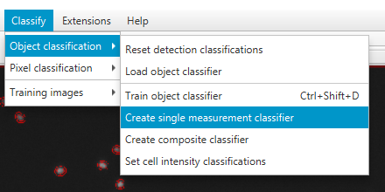
- Set up the classifier to identify the red cells and classify them as senescent
  - Note, the histogram and live preview are very useful tools when setting thresholds in cases like this.
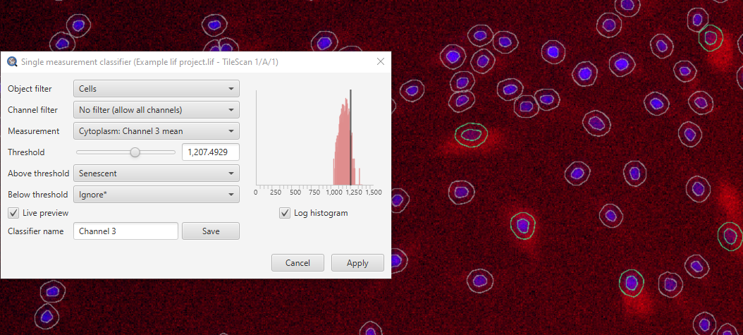
- Name and Save this classifier, then Apply.
- Have a look at these tools to alter how the they are visualised
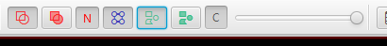
Opacity slider
Annotation (box) settings
Detection (cell) settings

Batch process images
- Go to the workflow tab
  - The main commands run have been recorded
- Create script
  - Remove everything other than the cell detection and Object Classifier commands
- Add any comments with “//” to annotate the code
- This is almost ready to run on all the images in the project. You just need a way of selecting the whole image before running the cell detection command (it needs a defined space to run in). Do this with:
createFullImageAnnotation(true)
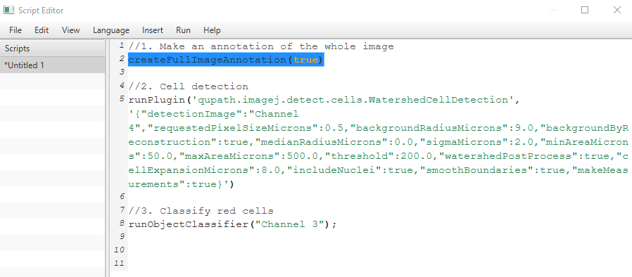

- Run for the whole project with Run >> Run for project
  - Choose the images you’d like to analyse. Just choose a few images for this demonstration, the whole lot will take a couple of minutes to run.
- Save the script. This will automatically save to a “Scripts” folder in your project folder. You can find it later in the Automate >> Project Scripts…. tabs.
- Your “Annotation” (i.e. the box within which the cells were detected) is in the Annotations tab (also states the number of objects (i.e. cells) within it.
- To see the box and the cells, go to the “Hierarchy” tab. You can se which objects are inside what (parent-child relationships), and individual measurements.
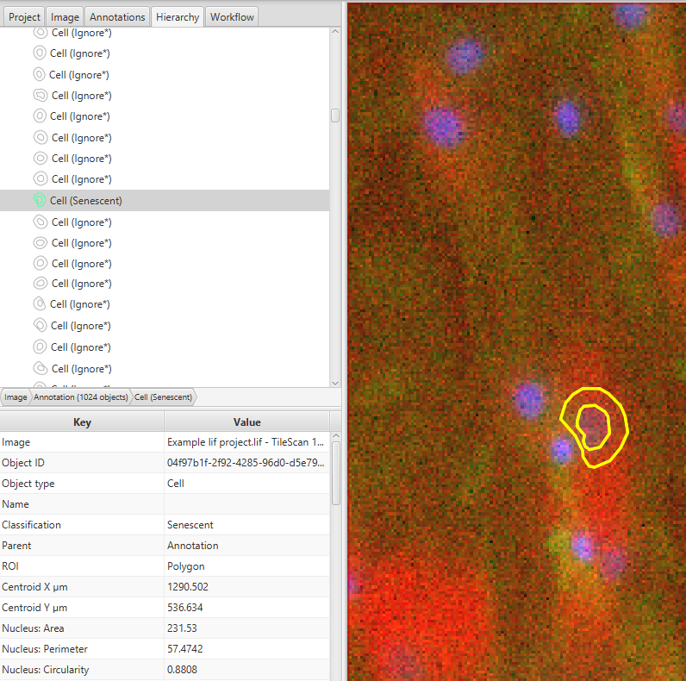
Selected cell
Measurements
Measurements
- You now have data for all the images analysed. This can be viewed (Measure >> Show Detection Measurements) and/or exported (Measure >> Export Measurements)
